
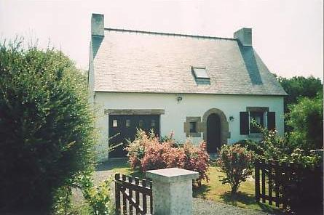

BOOKING FORM

Your Details
Name
Address
Postcode
Telephone Number
Email address
Number of Adults
Number of Children (& ages)

Rental Dates
Dates of Rental | From |  | To

Arrival Port

This is so we can send you directions to the house.

Payment Details
Price of Rental £ |  | Deposit Due £  (20% of rental price)
This deposit is non refundable.
Payment of the balance is due 6 weeks prior to the start of the holiday.
Please make cheques payable to Mr G Shaw
and send to: 38 Crown Road, Kingswood, Bristol BS15 1PR. There is also a £50 key deposit to be paid when paying the balance. This will be refunded when holiday is complete and key is returned.
I have read and agree to the Terms and booking conditions for Le Yaudet
Signature |  | Date

